Heaven's light is our guide
Rajshahi University of Engineering & Technology

Department of Computer Science & Engineering



Sessional (Lab Report)-02

Course Name : Data Communication Sessional
Course Code : CSE 3204
Experiment No : 02
Experiment Name : Analog-to-Digital Conversion (Sampling) Using PAM
Modulation & Time Division Multiplexing (TDM)
Date of Experiment : 25 Oct, 2025
Date of Submission : 03 Jan, 2026

Submitted by:  Roll Name  2103061 Md. Mushfiqur Rahman  2103062 Md. Rraf Hasan  2103063 Md. Raiyan Haque Ashwas  2103064 Md. Asad-Al-Adil  2103065 Md. Morakib Hossain  2103066 Md. Akibul Hasan | Submitted to:  Shyla Afroge  Associate Professor  Department of Computer Science and Engineering, RUET

1.Experiment name:
Analog-to-Digital Conversion (Sampling) Using PAM Modulation

Objective:
- This experiment explores the process of converting an analog signal into a discrete signal through sampling, followed by processing it through PAM modulation and demodulation stages.
- A 1 kHz analog input signal was sampled at a frequency of 32 kHz. The signal was then modulated, buffered, amplified, and demodulated to reconstruct the original signal.

Theory:
Analog-to-Digital Conversion (ADC) is a fundamental process in digital signal processing. It involves:
- Sampling: The continuous analog signal is measured at regular intervals (sampling frequency).
- Pulse Amplitude Modulation (PAM): A modulation technique where the amplitude of pulses represents the sampled signal.
- Buffering and Amplification: The signal is conditioned for further processing or transmission.
- Demodulation: Reconstructing the original signal from its modulated form.

According to the Nyquist-Shannon theorem, the sampling frequency must be at least twice the highest frequency of the analog signal to avoid aliasing.

Required Equipment:
- PAM/PWM/PPM Modulation/Demodulation Kit (Model TCM 001-02)
- Function Generator: Generates a 1 kHz analog input signal.
- Oscilloscope: Observes and verifies waveforms at different stages.
- DC Power Supply: Provides power to the modulation kit.

Pin connections:
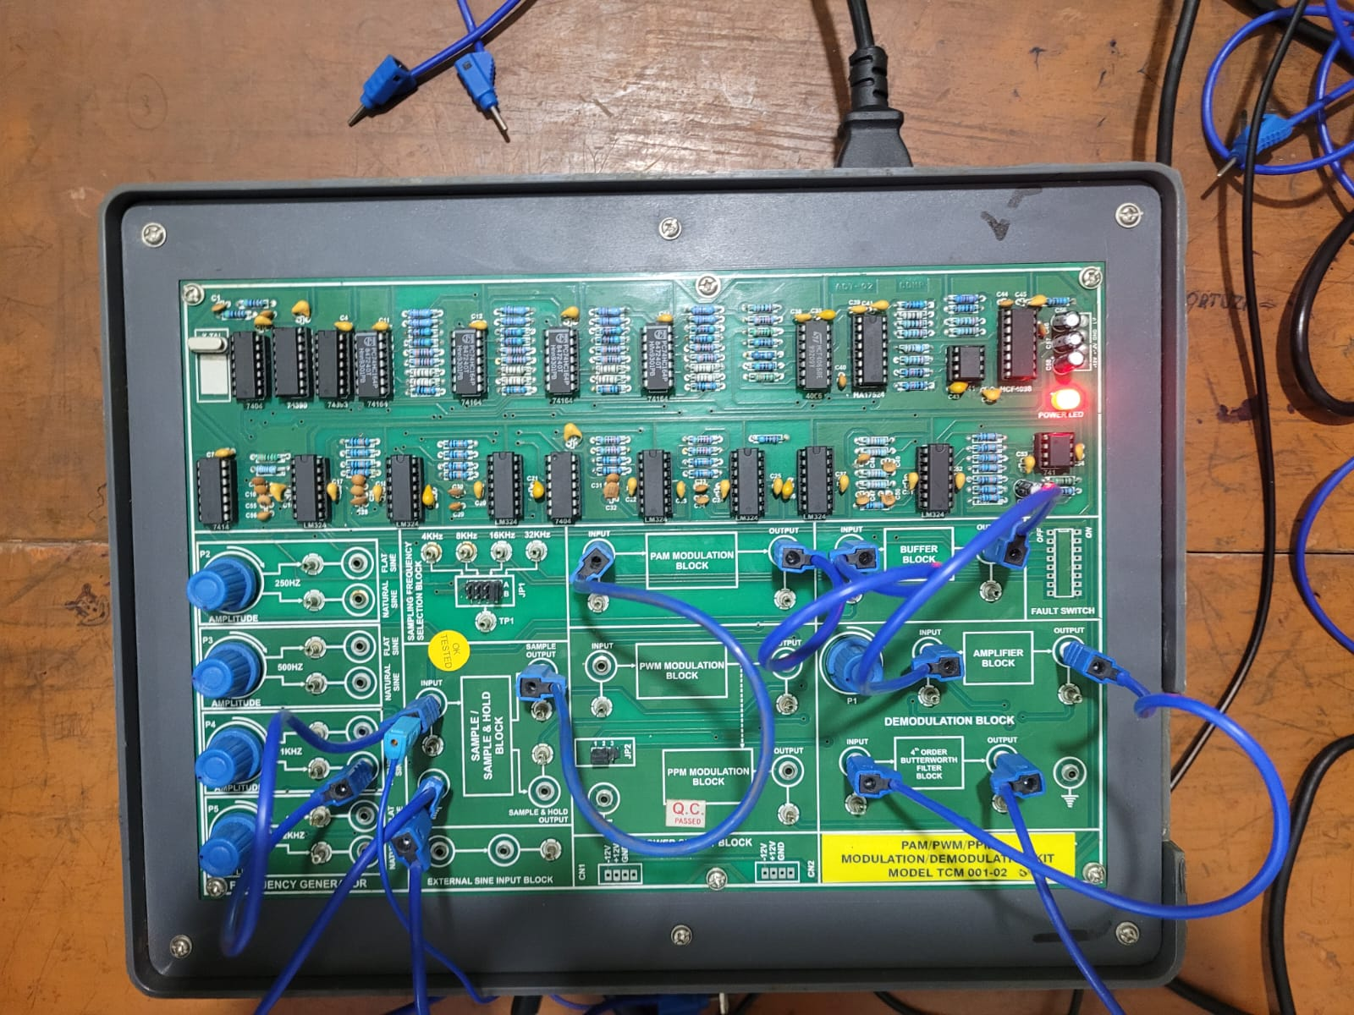

Procedure:
- Input Signal Generation: A 1 kHz sinusoidal signal was generated using the function generator and fed into the sampling block.

- Sampling Process: The sampling frequency was set to 32 kHz, ensuring compliance with the Nyquist criterion. The sampled output was observed on an oscilloscope to verify the discrete nature of the signal.

- PAM Modulation: The sampled signal was sent to the PAM modulation block. The PAM-modulated waveform was observed and recorded.

- Buffering and Amplification: The modulated signal was passed through the buffer block to stabilize it and then to the amplifier block to boost its strength.

- Demodulation: The amplified signal was sent to the demodulation block to reconstruct the original 1 kHz analog signal.

- Observation and Analysis: Outputs were observed at each stage using the oscilloscope and compared with the original input signal.

Output:
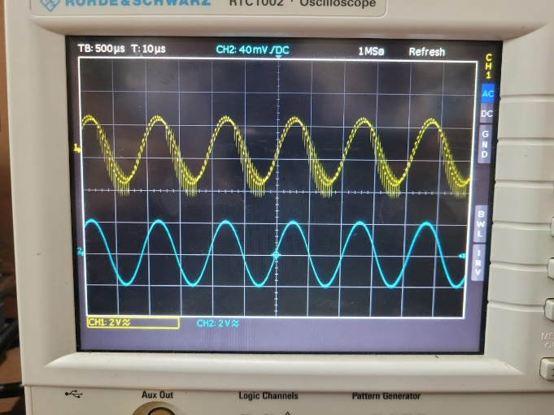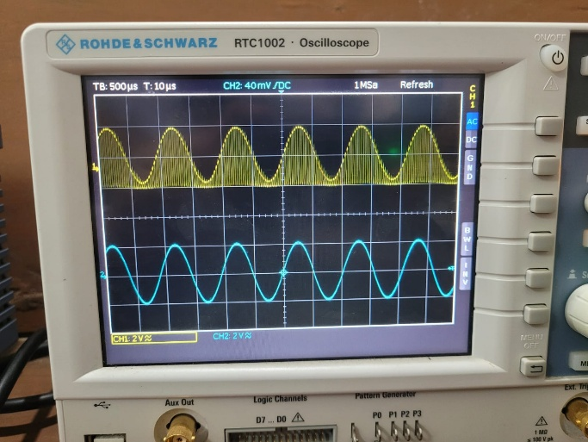
Fig-01:Using Sample Block Fig-02:Using PAM Modulation block

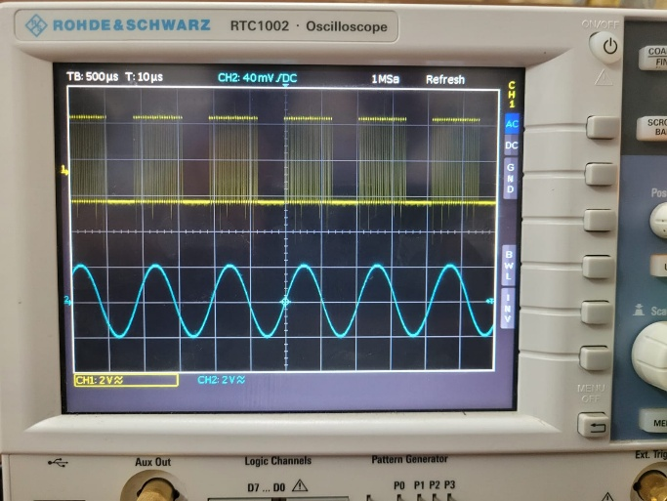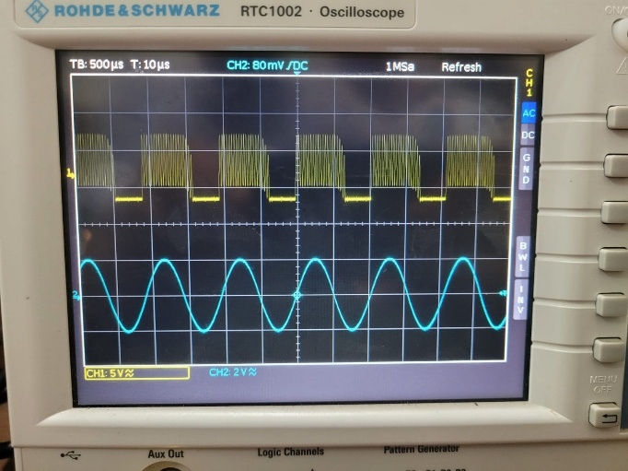
Fig-03: Using Buffer block Fig-04: Using Amplifier block

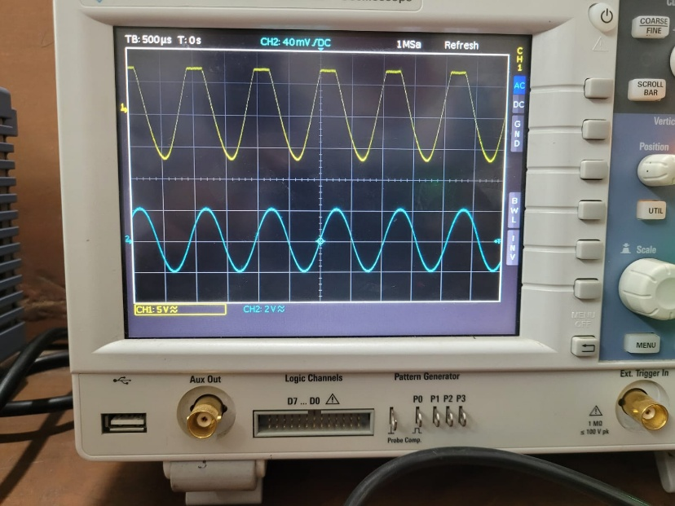
Fig-05: Using Demodulation block

Precautions:
- Preventing Overmodulation
- Set Frequencies Correctly
- Properly adjust the probes of the oscilloscope

Conclusion:
The experiment highlights key principles of analog-to-digital conversion:
- The importance of choosing an appropriate sampling frequency, as per the Nyquist theorem, to preserve the original signal's fidelity.
- The role of modulation techniques like PAM in encoding sampled data into a form suitable for transmission and processing.

2.Experiment name:
Time Division Multiplexing (TDM) for Transmission and Reception.

Objectives:
- To study the concept of Time Division Multiplexing (TDM)
- Perform data transmission of multiple analog signals through a single communication channel using a TDM trainer kit.

Theory:
Time Division Multiplexing (TDM) is a key technique that enables multiple signals to utilize a single transmission medium by employing time slicing methods while preserving signal quality.
Multiplexing combines multiple data streams for simultaneous transmission over a single medium. Among the various methods, Time Division Multiplexing (TDM) stands out by assigning specific time intervals to each signal, ensuring that every data stream is transmitted within its own designated slot.

Principles of Time Division Multiplexing:
TDM operates by splitting the available channel time into discrete intervals, with each interval allocated to a specific data source. Key aspects include:
- Time Slot Allocation: The transmission period is segmented into predefined slots, each designated for a particular data source to send its information.
- Synchronization: Precise synchronization between the transmitter and receiver ensures that the receiver can accurately detect the boundaries of each time slot.
- Channel Efficiency: By sharing time across sources, TDM optimizes channel usage, accommodating intermittent or irregular data transmissions.

There are two primary types of TDM:
- Synchronous TDM: Fixed time slots are assigned to sources, irrespective of whether they have data to send, which can result in unused bandwidth.
- Statistical (Asynchronous) TDM: Time slots are allocated dynamically based on real-time demand, improving bandwidth utilization but requiring more sophisticated control systems.

Transmission Process Using TDM:
TDM Transmitter Architecture: The TDM transmitter is designed to sequentially sample multiple input signals and assign them to specific time slots in a continuous sequence. Key components include:
- Multiplexer (MUX): Combines individual input channels into a single composite signal according to the time slot schedule.
- Timing and Control Unit: Generates precise clock signals to control the switching of input channels, ensuring each channel’s data is transmitted in its allotted time slot
- Analog-to-Digital Conversion: For analog signal sources, conversion to digital form is necessary before multiplexing.

Required Equipment:
- TDM Trainer Kit
- Two Analog Signal Sources
- Oscilloscope (Dual Channel)
- Patch Cords
- DC Power Supply

Pin connections:

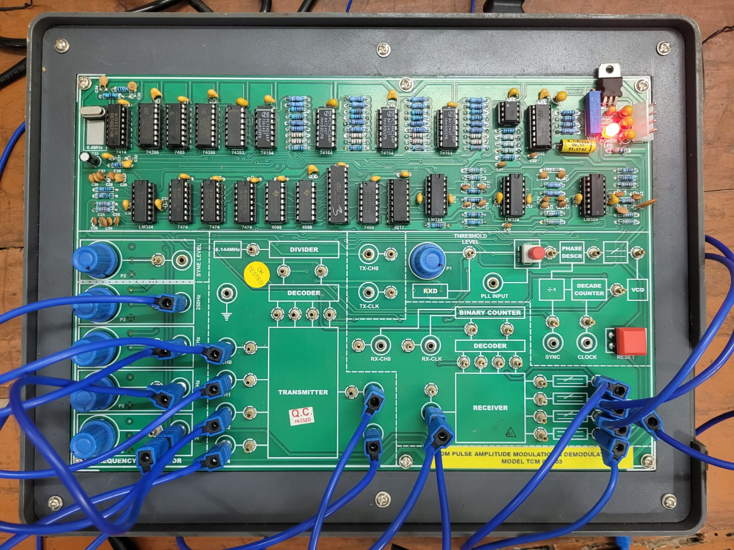

Procedure:
- System Design and Configuration: The TDM system was initially configured on simulation software to determine optimal time slot allocation and synchronization parameters.

- Data Transmission: Multiple data streams were input into the transmitter, which then combined the signals into a single composite data stream using predefined time slots.

- Signal Monitoring: The composite output signal was monitored in real time to assess the clarity and timing precision.

- Reception and Demultiplexing: The composite signal were then fed into the receiver system. The demultiplexer extracted the individual signals based on the known time slot schedule.

- Error Analysis: Data integrity was verified by comparing the transmitted and received data streams, with particular attention to synchronization errors and any signal distortion.

Output:

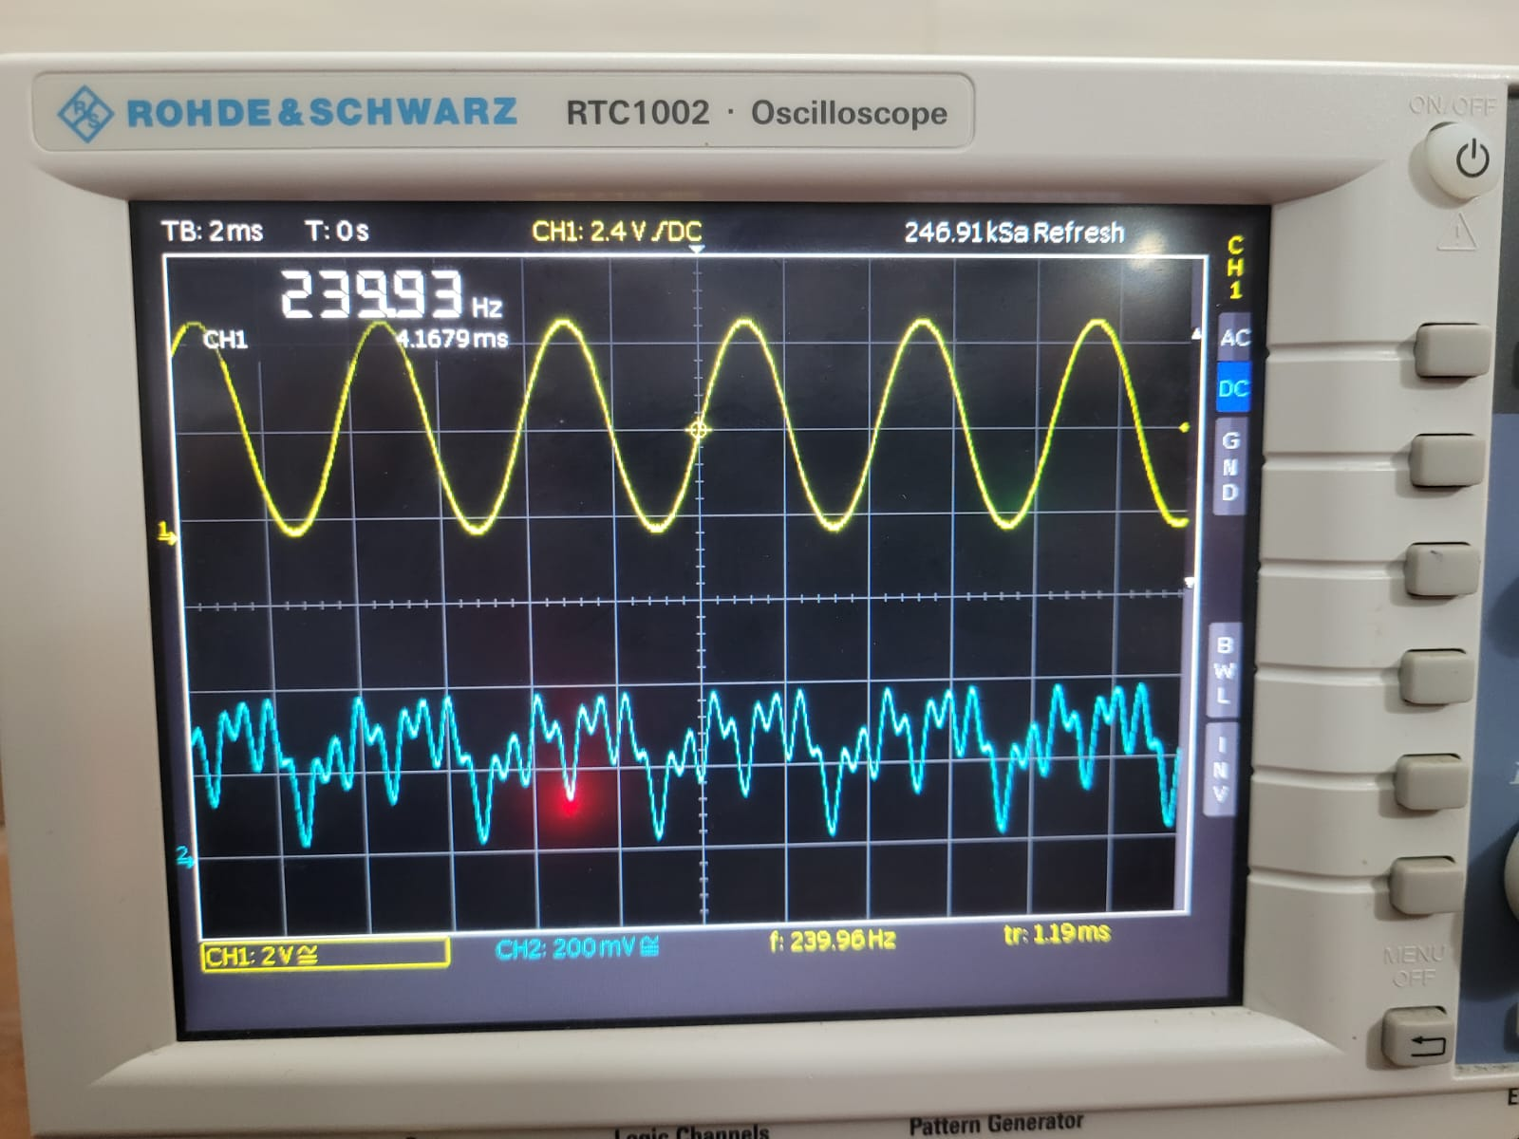
Fig-01: 250Hz Signal (Input and Multiplexed Signal)

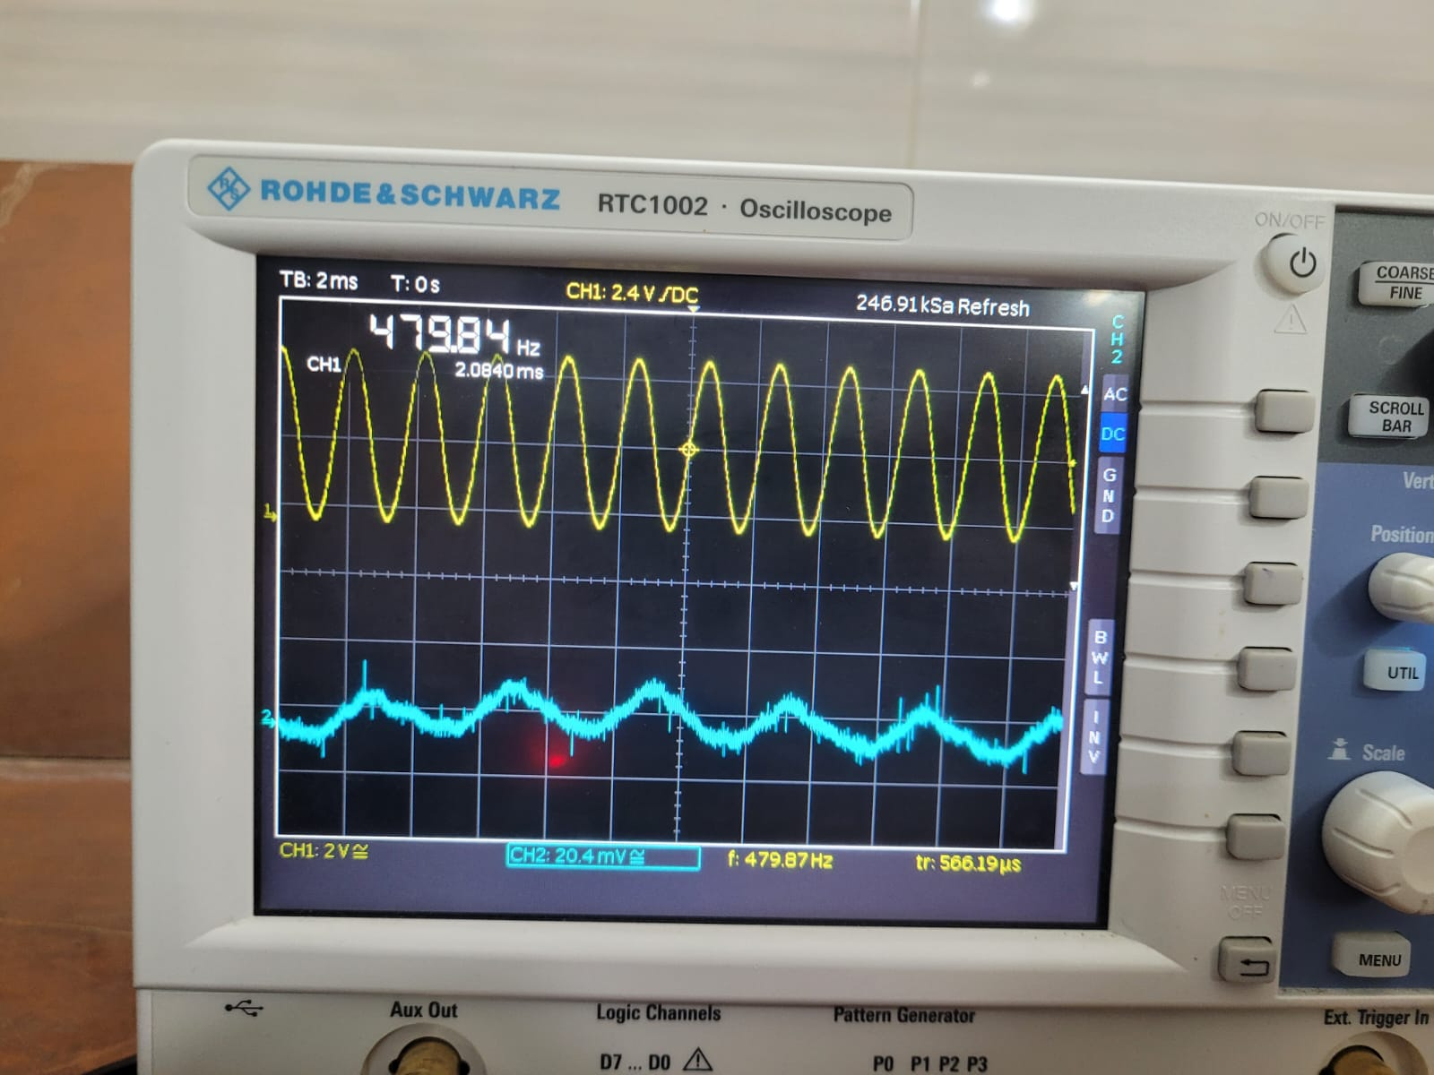
Fig-02: 500Hz Signal (Input and Multiplexed Signal)

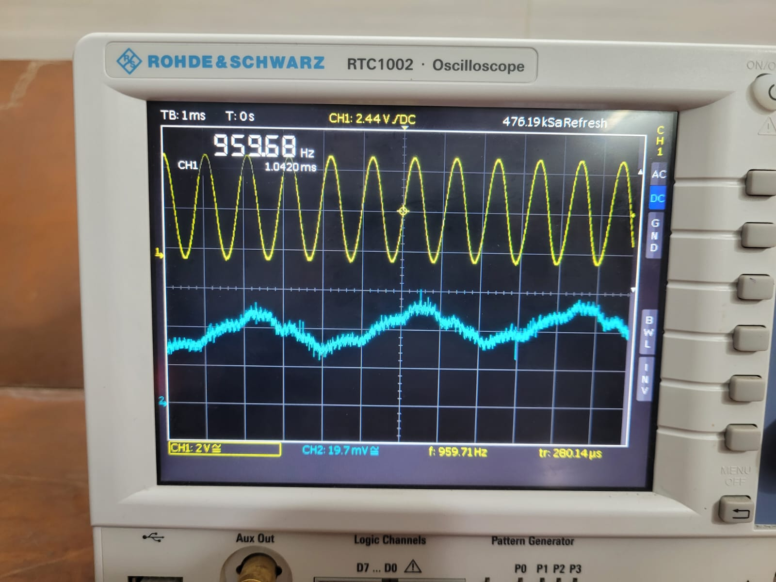
Fig-03: 1kHz Signal (Input and Multiplexed Signal)

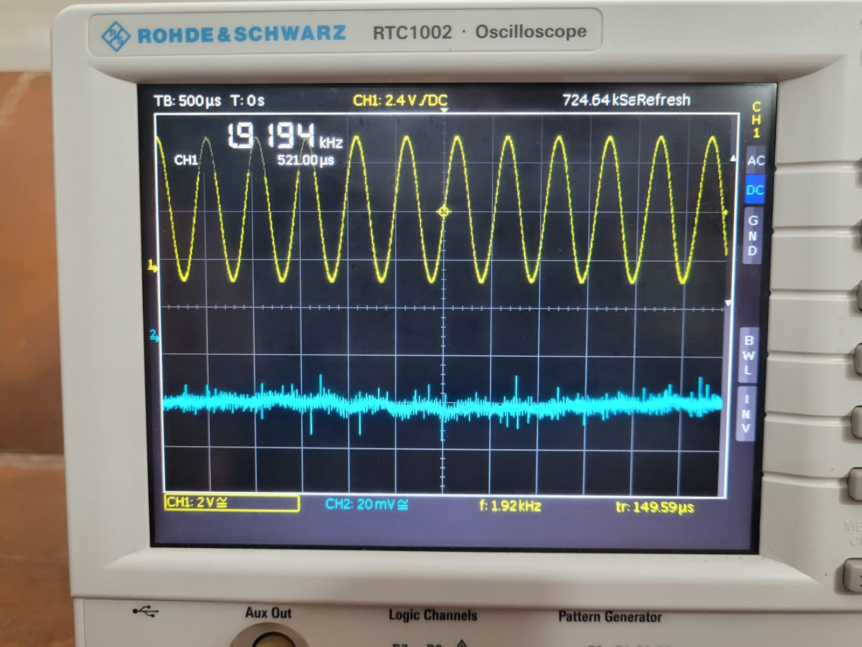
Fig-04: 2kHz Signal (Input and Multiplexed Signal)

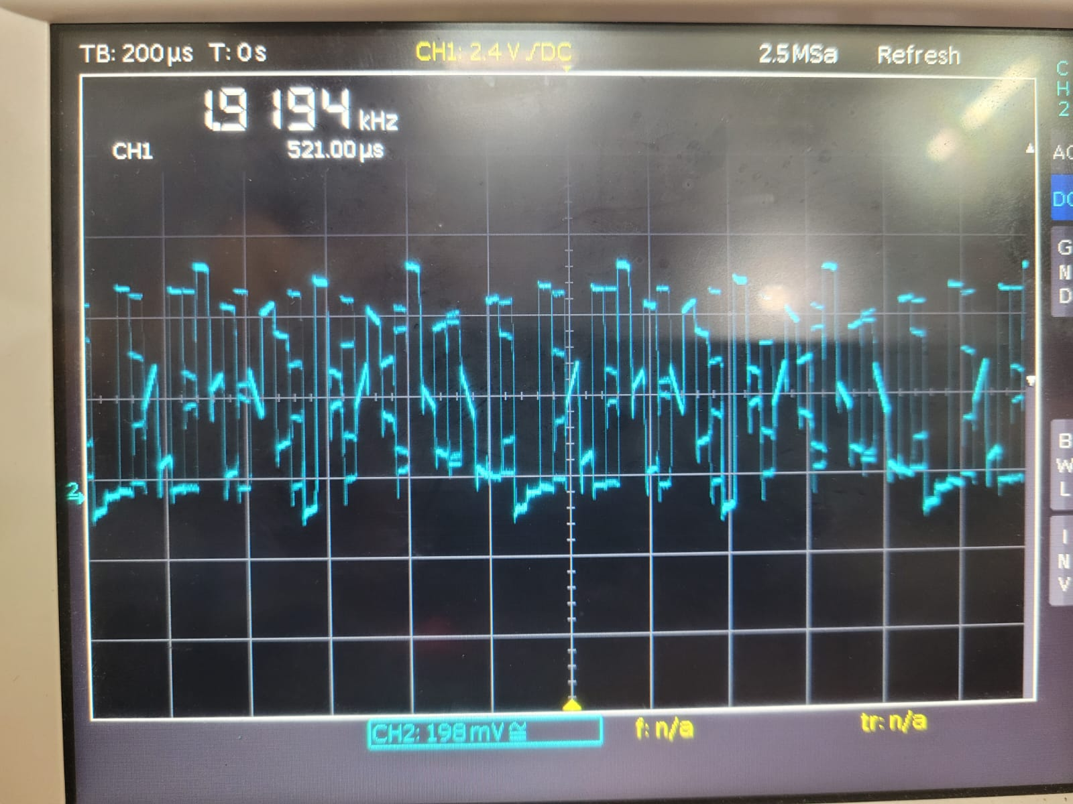
Fig-04: 2kHz Signal (Multiplexed Signal)

Precautions:
- Maintain Correct Frequency Ratio
- Avoid Over-Deviation (Distortion)
- Connect the oscilloscope’s probe properly to see the signal.

Conclusion:
Time Division Multiplexing (TDM) provides a dependable and effective solution for transmitting multiple data streams concurrently over a single channel. Laboratory experiments highlight TDM's adaptability and functionality across both stable and dynamic scenarios. While challenges such as synchronization and time slot management persist, TDM continues to serve as a foundational technology in contemporary digital communication systems. The knowledge gained from its practical application offers essential guidance for developing and refining future multiplexing technologies.

